Date: |  |  |  |  | Duration:  (hours) |  |  | Client code | XXX |  | Session  # | YY
Previous session’s follow-up | Starting weight? |  |  |  | Current weight? |  |  |  | Loss?
 | Other parameters |  |  |  | App use? |  |  |  | Challenges done?
Notes re challenges done etc
Save as PreKure/DoneWorksheets/XXXAbCd/XXX-YYCoachingWorksheet - don’t save over the template, update file name.

Clearances | Confidentiality |  |  |  | Consent to coach? |  |  | OK to Record for  Qlty& Trng? |  |  | Permission to share advice?
A - Topic: | This session’s focus/expected outcomes. REM; tell the client “You hold the agenda”, it’s about you, not me, I’m just here to help with the process”.
B - Summary of discussion | 1 | Motivation drivers & dreams |  |  | (Power question prompts & techniques table overleaf):
 | 2 | Fears & worries, |  |  | (Power question prompts & techniques table overleaf):
 | 3 | Obstructions & impediments, |  |  | (Power question prompts & techniques table overleaf):
 | 4 | External, other people, |  |  | (Power question prompts & techniques table overleaf):
 | 5 | Self, moving forward, |  |  | (Power question prompts & techniques table overleaf):
 | 6 | Internal |  |  | (Power question prompts & techniques table overleaf):
 | 7 | Other |  |  | (Power question prompts & techniques table overleaf):
C - How I closed the session? | Challenges; |  |  |  | Accountability; |  |  | Another session (Y/N date); |  |  | Other:
D - What worked well? | Which tools helped?
E - What I could have done differently? | Which extra tools/questions could/should I have used? (Health Warning, second guessing, post event wisdom!)
F - What did I learn from this session? | Positive
 | Negative
G –Nutrition & lifestyle? (check X) | Not addressed this time |  |  |  |  | Came up in conversation |  | Becoming interested |  |  | Main topic of conversation
Information sharing & corrective action planning (check X to show);
Information share (experiences, videos, references, recipes, demos etc) |  | PDCA (Plan-Do-Check-Act); inc GRIN below
Behaviour change process (IMO, this needs to change beliefs to stand any chance of enduring success...)
GRIN Behaviour change, Dr Jen Unwin,  Goals,  Resources & resilience,  Increments,  Noticing,  https://www.youtube.com/watch?v=44K8o9FWAWQ | 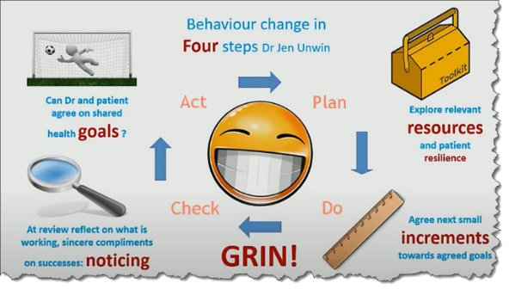
Notes

Power question prompts used in the conversation this time, please circle/shade to show;

Health coaching techniques used this session, please check X to show;
MI | HC Technique |  | Check | MI | HC Technique | Check
Open-ended questions | Adverse Childhood Experiences (ACE); leading to Trauma Informed Practice (TIP - UK NHS) |  |  | Affirm | Acknowledgement (you’re brave…)
 | Flip it (on its head…) |  |  |  | Championing (I get it, well done…)
 | Intrude/interrupt (eye on the ball…) |  |  | Reflective listening | Active listening (dive deeper/name it)
 | Investigation (5Ys, Kipling’s 5Ws+1H, Reason Swiss Cheese Model) |  |  |  | Intuition
 | Kubler-Ross | 5 stages of grief; (not the ultimate anymore)  Denial, Anger, Bargaining, Depression, Acceptance |  |  | Metaphor/simile
 | Power questions (prompts above…) |  |  |  | NLP (Neurolinguistic programming)
 | Resonance/dissonance (yes &/yes but) |  |  |  | Silence (wait for it...)
 | Saboteur (all change is bad…the machine) |  |  | Summary | Accountability (client on the hook…set/accept challenges)
 | SPIN (Situation-Problems-Implications-Needs) |  |  |  | Articulating what’s going on
 | The Line | Victor OAR –  - Ownership, Accountability, Responsibility |  |  | Bottom-lining (OK, here’s the thing...)
 |  | Victim BED –  Blame, Excuses, Denial |  |  | Reframing (look for the good stuff…)
MI= Health Coaching techniques vs Motivational Interviewing (OARS) i.e. Open-ended questions, Affirmations, Reflective listening, Summary
Notes

END

